LOCAL binary pattern based Segmentation

DIP Assignment 3

By

SHREYA K.R

140907759

ECE-D, Roll no 60





Department of Electronics and Communication Engineering

MANIPAL INSTITUTE OF TECHNOLOGY

(A Constituent Institute of Manipal University)

**INTRODUCTION**

Local Binary Patterns are an excellent tool for texture analysis. They serve as an excellent way to measure texture. Two textures can easy have very similar histograms but their histogram in the local binary pattern space will be quite different. Thus, in case of images where different objects have different texture, with similar histograms, Local Binary Patterns can be used as very efficient tools for segmentation.

A local binary pattern operator involves thresholding the neighbouring pixels with the centre pixel and then multiplying each number in the post thresholding matrix with its position-wise decimal equivalent. This means, if a neighbouring pixel is greater than, or equal to the centre pixel, its value will become 1 and if it less than the centre pixel, its value will be 0. The first pixel will then be multiplied by 1, the second by 2, the third by 4 and so on. This operation is illustrated in the following figure.

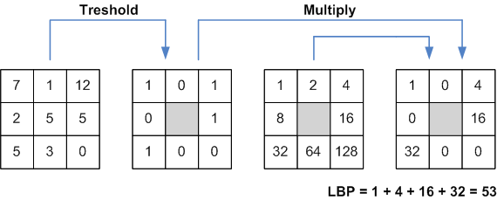

*Fig 1: The Local Binary Pattern Operator*

The local binary pattern has been used in combination with histogram of oriented gradients for accurate segmentation. It has also recently found applications in facial recognition and identification of facial expressions. This makes use of texture descriptors from different regions of the face to apply the LBP Operator to. In all these applications, histogram of the LBP space image is used for processing, in place of the ordinary intensity histogram.

**LITERATURE SURVEY**

|  |  |  |  |  |
| --- | --- | --- | --- | --- |
| **Year** | **Author** | **Title** | **Keywords** | **Remarks** |
| **2017** | [SunhuaWan](http://www.sciencedirect.com/science/article/pii/S1361841517300385" \l "!)  [Hsiang-ChiehLee](http://www.sciencedirect.com/science/article/pii/S1361841517300385#!)  [Xiaolei Huang](http://www.sciencedirect.com/science/article/pii/S1361841517300385#!) | Integrated local binary pattern texture features for classification of breast tissue imaged by optical coherence microscopy | Optical coherence,  microscopy,  Tissue classification,  Texture, features,  Local binary patterns | In order to improve classification accuracy, this paper proposes novel variants of LBP features, namely average LBP (ALBP) and block based LBP (BLBP). Compared with the classic LBP feature, ALBP and BLBP features provide an enhanced encoding of the texture structure in a local neighbourhood by looking at intensity differences among neighbouring pixels and among certain blocks of pixels in the neighbourhood. |
| **2016** | Mehta, Rakesh, and Karen Egiazarian | Dominant rotated local binary patterns (DRLBP) for texture classification | Texture Classification,  Local Binary Pattern (LBP),  Rotation Invariance,  Feature Selection | A novel rotation-invariant and computationally efficient texture descriptor called Dominant Rotated Local Binary Pattern (DRLBP) is found. The proposed approach not only retains the complete structural information extracted by LBP, but it also captures the complimentary information by utilizing the magnitude information, thereby achieving more discriminative power. |
| **2016** | Guo, Zhenhua | Robust texture image representation by scale selective local binary patterns | [Feature extraction](http://ieeexplore.ieee.org/search/searchresult.jsp?matchBoolean=true&queryText=%22Index%20Terms%22:.QT.Feature%20extraction.QT.&newsearch=true),  [Histograms](http://ieeexplore.ieee.org/search/searchresult.jsp?matchBoolean=true&queryText=%22Index%20Terms%22:.QT.Histograms.QT.&newsearch=true),  [Databases](http://ieeexplore.ieee.org/search/searchresult.jsp?matchBoolean=true&queryText=%22Index%20Terms%22:.QT.Databases.QT.&newsearch=true),  [Grey-scale](http://ieeexplore.ieee.org/search/searchresult.jsp?matchBoolean=true&queryText=%22Index%20Terms%22:.QT.Gray-scale.QT.&newsearch=true),  [Fractals](http://ieeexplore.ieee.org/search/searchresult.jsp?matchBoolean=true&queryText=%22Index%20Terms%22:.QT.Fractals.QT.&newsearch=true), [Training](http://ieeexplore.ieee.org/search/searchresult.jsp?matchBoolean=true&queryText=%22Index%20Terms%22:.QT.Training.QT.&newsearch=true) | A new method based on dominant LBP in scale space is proposed to address scale variation for texture classification is developed. First, a scale space of a texture image is derived by a Gaussian filter. Then, a histogram of pre-learned dominant LBPs is built for each image in the scale space. Finally, for each pattern, the maximal frequency among different scales is considered as the scale invariant feature. |
| **2016** | Liu, L., Fieguth, P., Zhao | Extended local binary patterns for face recognition | Face recognition  Feature extraction  Local binary pattern  Local descriptors | This paper presents a simple and novel, yet highly effective approach for robust face recognition. Using LBP-like descriptors based on local accumulated pixel differences – Angular Differences and Radial Differences, the local differences were decomposed into complementary components of signs and magnitudes. Based on these descriptors dominant patterns where the most frequently occurring patterns and their labels were learned to capture discriminative textural information. |
| **2016** | [Juha Ylioinas](http://www.sciencedirect.com/science/article/pii/S0031320316301467" \l "!)  [Norman Poh](http://www.sciencedirect.com/science/article/pii/S0031320316301467#!)  [Jukka Holappa](http://www.sciencedirect.com/science/article/pii/S0031320316301467#!)  [Matt Pietikäinen](http://www.sciencedirect.com/science/article/pii/S0031320316301467#!) | Data-driven techniques for smoothing histograms of local binary patterns | Local binary patterns  Local binary descriptors  Histogram  Soft-assignment  Kernel density estimation | Local binary pattern histograms have proved very successful texture descriptors. Despite this success, the description procedure bears some drawbacks that are still lacking solutions in the literature. One of the problems arises when the number of extractable local patterns reduces while their dimension increases rendering the output histogram descriptions sparse and unstable, finally showing up as a reduced recognition rate. A smoothing method based on kernel density estimation was recently proposed as a means to tackle the aforementioned problem. |
| **2016** | Wang, Jiakailin | A Face Recognition System Based on Local Binary Patterns and Support Vector Machine for Home Security Service Robot. | [support vector machine](http://ieeexplore.ieee.org/search/searchresult.jsp?matchBoolean=true&queryText=%22Index%20Terms%22:.QT.support%20vector%20machine.QT.&newsearch=true),  [face recognition](http://ieeexplore.ieee.org/search/searchresult.jsp?matchBoolean=true&queryText=%22Index%20Terms%22:.QT.face%20recognition.QT.&newsearch=true),  [stranger identification](http://ieeexplore.ieee.org/search/searchresult.jsp?matchBoolean=true&queryText=%22Index%20Terms%22:.QT.stranger%20identification.QT.&newsearch=true),  [home security service robot](http://ieeexplore.ieee.org/search/searchresult.jsp?matchBoolean=true&queryText=%22Index%20Terms%22:.QT.home%20security%20service%20robot.QT.&newsearch=true),  [local binary patterns](http://ieeexplore.ieee.org/search/searchresult.jsp?matchBoolean=true&queryText=%22Index%20Terms%22:.QT.local%20binary%20patterns.QT.&newsearch=true) | The face recognition system proposed in this paper, where the camera was used to capture the video stream, can automatically detect and track the human face in the image frame, and then recognize the human's identity. However, the human faces in the video frame are not always completely front faces. Hence, the method should be able to detect the face with angle. According to some recent researches, the common methods of face detection include harr-like feature and LBP feature. It is found that LBP works better in incomplete frontal human faces. |
| **2011** | Ding, Youdong | Recognition of hand-gestures using improved local binary pattern | Image coding, training , feature extraction, robustness, support vector machine | Hand gestures is an important form among people, hand-gesture recognition has become an important application in HCIS, because keyboard and mouse cannot satisfy people's interacting requirements to be great extent. Up to now, there have been many successful algorithms for hand-gesture recognition, but there are still some factors affecting the performance of the hand-gesture recognition, say, illumination, masking, etc. Therefore, the main tasks for hand-gesture recognition are to find better methods for features extraction and robust classification. |
| **2011** | Pietikäinen, Matti | Local binary patterns for still images | LBP,  Texture,  LBP Variants,  Feature selection | The generic LBP operator, and its rotation-invariant and multiscale versions are introduced. The use of complementary contrast information is also discussed. The success of LBP methods in various computer vision problems and applications has inspired much new research on different variants. |
| **2009** | Liao, Shu, Max WK Law | Dominant local binary patterns for texture classification | [image texture](http://ieeexplore.ieee.org/search/searchresult.jsp?matchBoolean=true&queryText=%22Index%20Terms%22:.QT.image%20texture.QT.&newsearch=true),  [feature extraction](http://ieeexplore.ieee.org/search/searchresult.jsp?matchBoolean=true&queryText=%22Index%20Terms%22:.QT.feature%20extraction.QT.&newsearch=true),  [Gabor filters](http://ieeexplore.ieee.org/search/searchresult.jsp?matchBoolean=true&queryText=%22Index%20Terms%22:.QT.Gabor%20filters.QT.&newsearch=true),  [image classification](http://ieeexplore.ieee.org/search/searchresult.jsp?matchBoolean=true&queryText=%22Index%20Terms%22:.QT.image%20classification.QT.&newsearch=true) | This paper proposes a novel approach to extract image features for texture classification. It comprises of two sets of features: dominant local binary patterns (DLBP) in a texture image and the supplementary features extracted by using the circularly symmetric Gabor filter responses. The dominant local binary pattern method makes use of the most frequently occurred patterns to capture descriptive textural information, while the Gabor-based features aim at supplying additional global textural information to the DLBP features |
| **2002** | Pietikäinen, Matti | Colour texture classification with colour histograms and local binary patterns. | Colour histograms,  Local binary pattern,  Texture classification | The approaches proposed for colour texture discrimination can be divided into two types: 1) colour and texture information are processed separately, and 2) spatial interactions of pixels both within and between colour bands are considered. An approach is proposed based on separate processing of complementary colour and pattern information. Colour histograms contain very discriminative colour information, while the distributions of Local Binary Patterns are used to provide robust pattern-related information |

**METHODOLOGY**

The **flowchart** of the algorithm used to achieve local binary pattern based segmentation, which is a modified version of the algorithm presented in the base paper, is as follows:

Take input image from user

Let the center pixel in the final image be the same as the pixel in the original image.

Has the entire LBP image been covered by the small windows?

Apply Local Binary Pattern Operator to the whole image

Select a rectangular region with texture 1 from the LBP applied image

Find the normalized histogram of this rectangular region

Yes

Select a rectangular region of texture 2 from LBP applied image

Find normalized histogram of this rectangular region

No

Take a small window, slide it over the image, finding the difference between the histogram of the window and the histogram of the texture you want to segment it with respect to

Is the sum of differences larger than threshold?

No

Yes

Make the center pixel of the window 0 (i.e. black)

**IMPLEMENTATION**

To implement Local Binary Pattern based segmentation in MATLAB, based on the above flowchart, the following functions were developed:

1. **deci.m** : This function acts as the local binary pattern operator. When a 3X3 matrix is fed to this function, it **returns a decimal value** corresponding to the matrix. This is done by :

* Thresholding the neighboring pixels with respect to the center pixel, i.e. if the neighboring pixels are greater than/ equal to center pixel, the value will become one, else 0.
* Multiplying each location in the matrix with its corresponding decimal value and then taking the sum to obtain the final decimal number corresponding the center pixel.

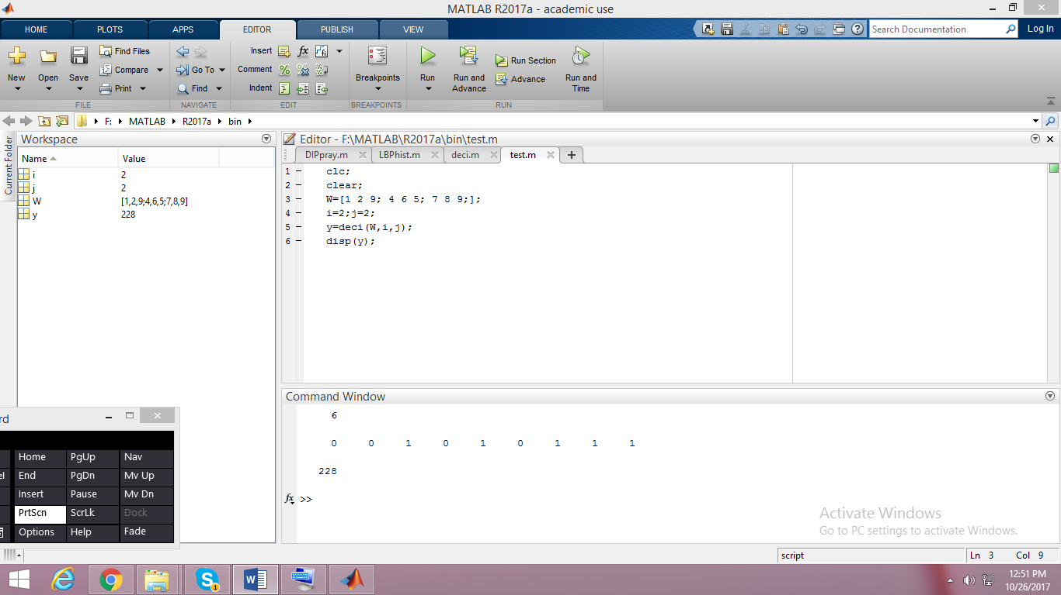

*Fig 2: The post thresholding values and final decimal value for a 3X3 example, generated by deci.m*

1. **LBPhist.m**: This function assigns the decimal values returned by the deci.m function to each center pixel of each 3X3 window, thereby generating an image in the LBP space. Since the maximum decimal value returned by deci.m is 255, it is possible to represent images this way, in greyscale representation. This function also finds an LBP histogram with 16 bins.

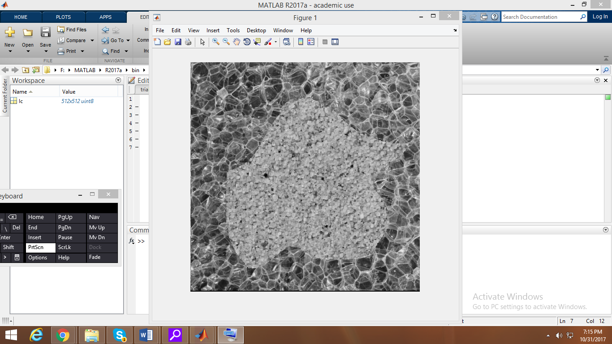 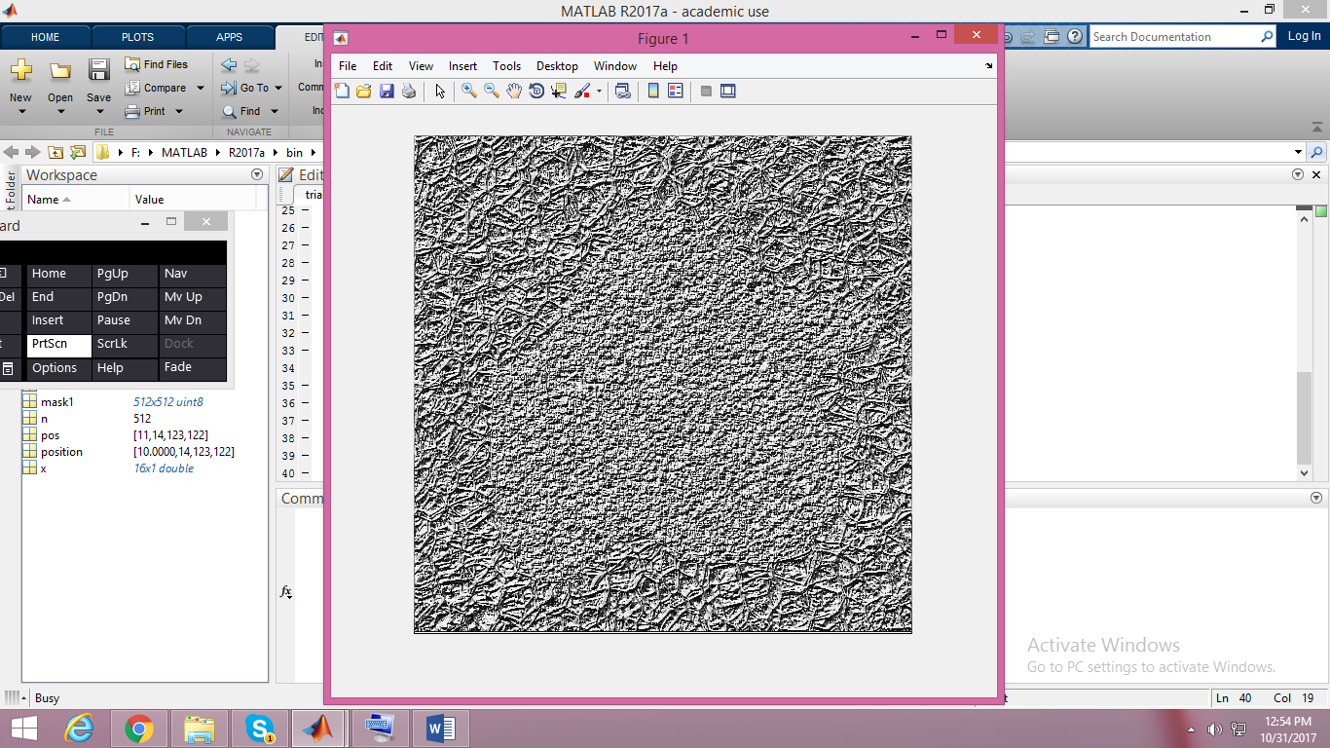

*Fig 3: The original image and the LBP operated image generated by LBPhist.m*

1. **Findhist.m :** When a particular center pixel is given to it, this function first constructs a 51X51 window around the center pixel, finds the histogram of this window and finally normalizes the histogram such that the sum of the values of the histogram become one. This is done so that histogram of windows of unequal sizes can be easily compared.

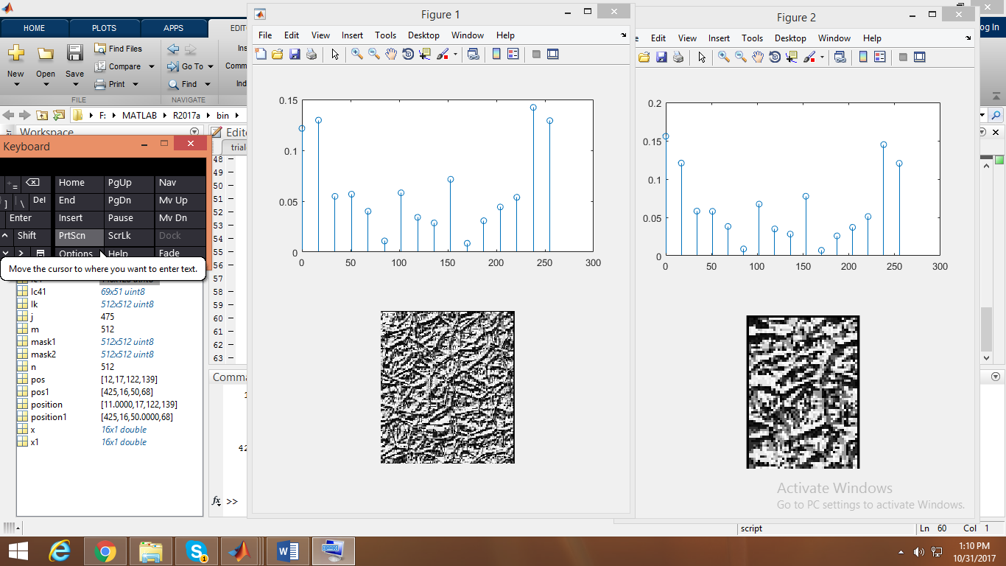

*Fig 4: Normallised histograms of two windows of different sizes but same texture generated by findhist.m*

1. **Comphist.m:** This function is used to compare two normalized histograms. This is done by subtracting the value of each bin of one histogram from the other, and adding the absolute values of these differences. The sum of differences is returned by this function which is later used as a thresholding value.
2. **Trialdip.m:** This is the main function that brings together all the above functions to implement the algorithm given in the flowchart. The LBP applied image is generated using LBPhist.m This function allows the user to select a rectangular region for each texture in the LBP applied image using a customizable rectangle. These rectangular regions each are fed to the findhist.m function. Finally the entire image is divided into several tiny windows, and the histograms of the textures and each tiny window are compared to find the differences using findhist.m and hence the intensity of the pixel in the segmented output. It gives a segmented output image for both cases, i.e. with respect to texture 1 and with respect to texture two.

**RESULTS**

When an image with two different textures was segmented using LBP based segmentation, the following results were obtained:

1. **Original Image:**



1. **Local Binary Pattern Operated image:**



1. **Segmented image with respect to Bubble Texture:**

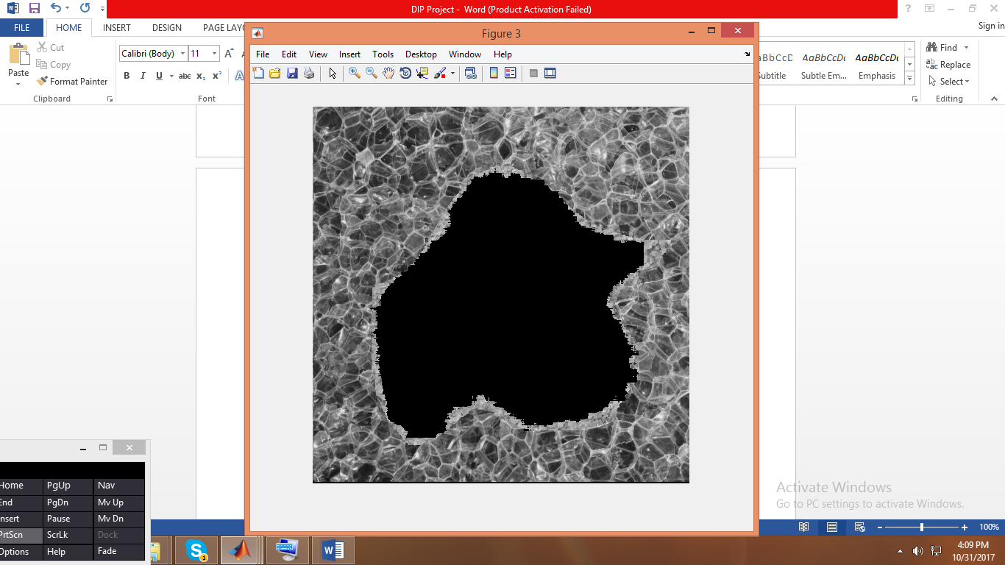

1. **Segmented Image with respect to Sand texture:**

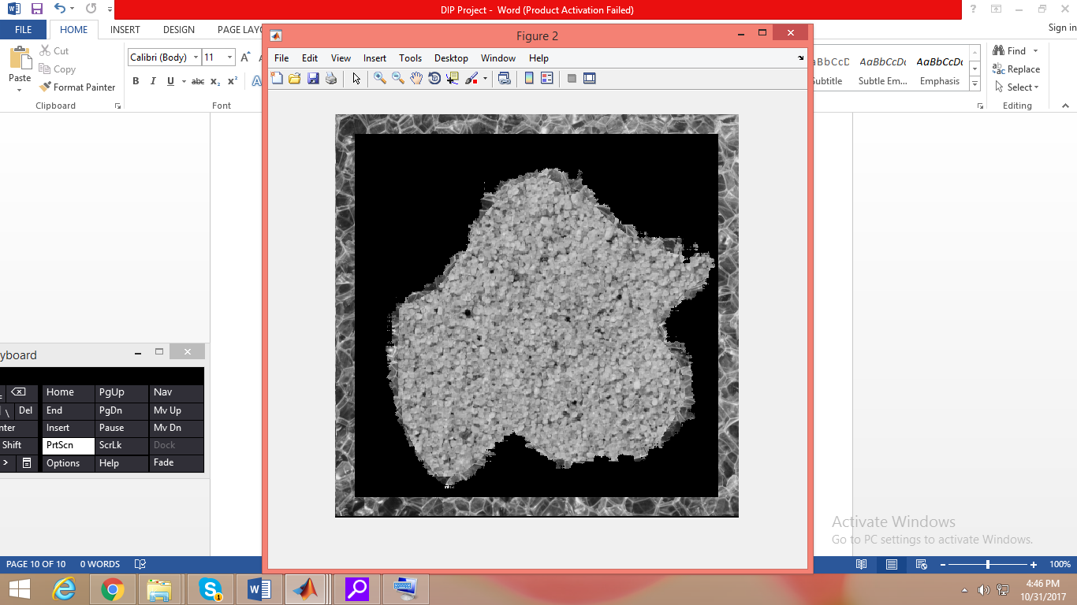

There is a boundary of the bubble texture that isn’t black. This is owing to the fact that with a window size of 51X51, the beginning pixel to be processed will be Image matrix pixel (26, 26). This can be avoided by padding the image with similar pixels around the edges.

**MERITS AND DEMERITS**

1. **Merits:**

* This method is extremely useful when an image with objects of multiple textures, has to be segmented into constituent objects.
* This method is rotation invariant in the LBP space. Once the LBP image is obtained, if objects are rotated or their angles are changed, their LBP histogram will still match with the LBP histogram of the original texture.
* When intensity based histograms are extremely similar in two textures due to the distribution of their intensity, this method is highly effective to differentiate between textures.

1. **Demerits:**

* To get very precise edges, the window size needs to be extremely small. This way, each window will capture only one texture region. However, a very small window will not capture enough information about the texture in its histogram.
* This method doesn’t give very accurate edges in the segmented objects. Hence it must be combined with other methods, for higher edge precision
* It is computationally extensive. Each window needs to have its histogram constructed and compared with the texture histogram. For large images, it can take a very long time.

**REFERENCES:**

[1] Tekeli, Erkin, Müjdat Çetin, and Aytül Erçil. "Shape and data driven texture segmentation using local binary patterns." *Signal Processing Conference, 2007 15th European*. IEEE, 2007. (**BASE PAPER**)

[2] <https://in.mathworks.com/help/vision/ref/extractlbpfeatures.html>

[3] <https://www.pyimagesearch.com/2015/12/07/local-binary-patterns-with-python-opencv/>